

BIRZEIT UNIVERSITY

Electrical and Computer Engineering Department

ENCS4310, Digital Signal Processing Assignment 1

Student Name: **Saif Battah**.

Student ID#: **1170986**

Sec#: **3**.

Instructor: **Dr.Qadri Mayyala**.

Date: **13/01/2023**

Part 1

Q1

1. Code:

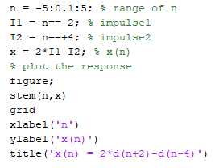

Plot:

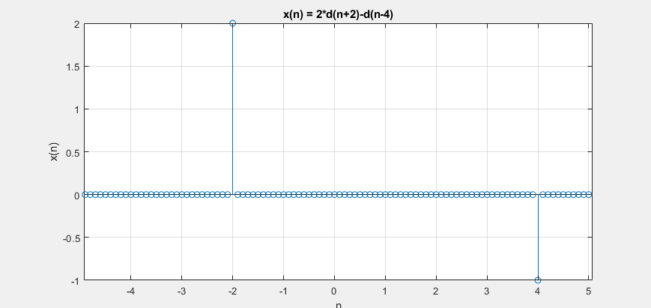

1. Code:

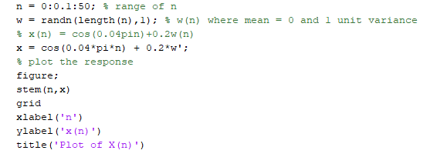

Plot:

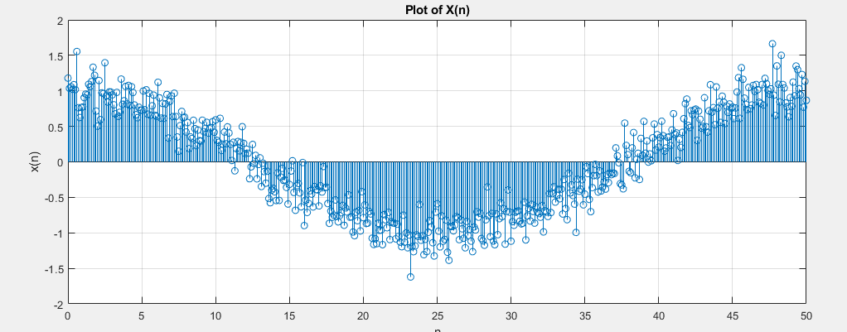

1. Code:

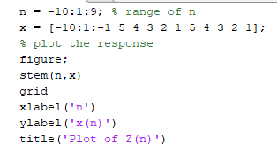

Plot:

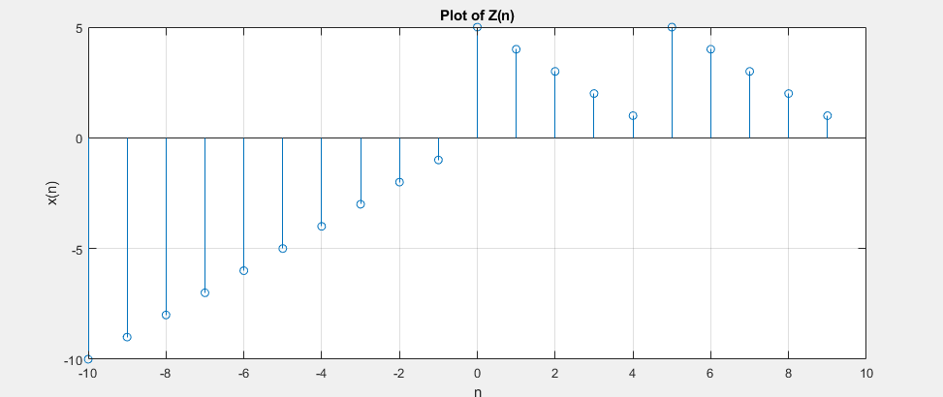

Q2

1. Code:

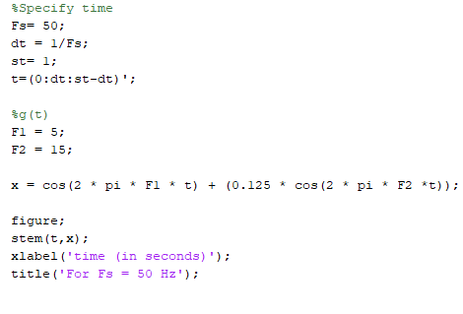

Plot:

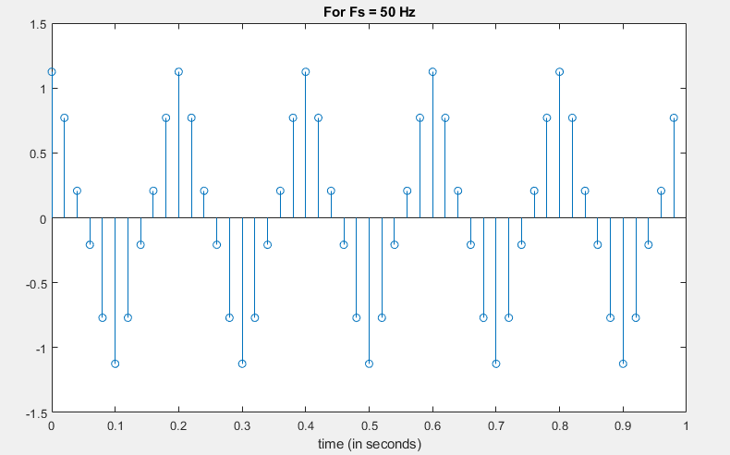

1. Code:

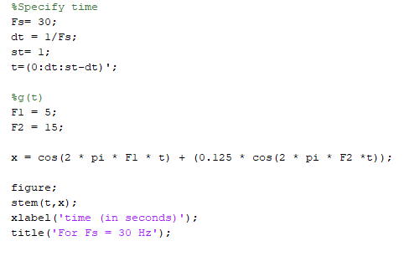

Plot:

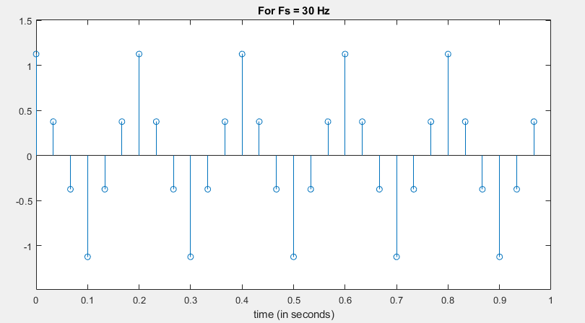

1. Code:

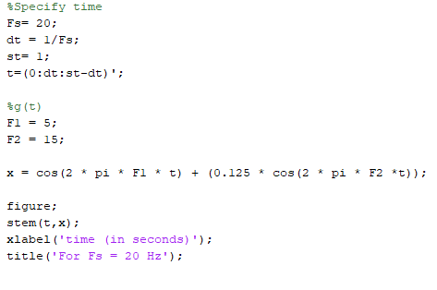

Plot:

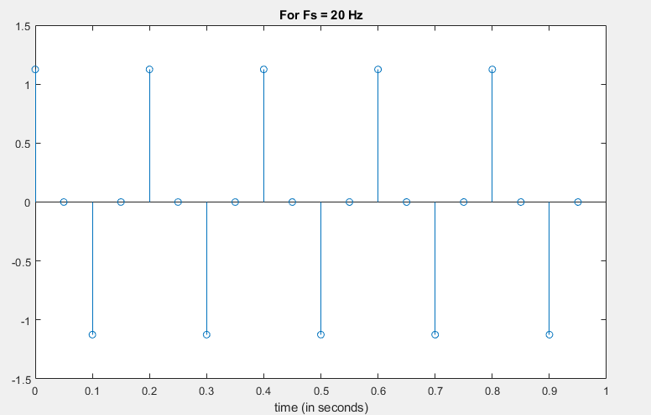

Q3

Code:

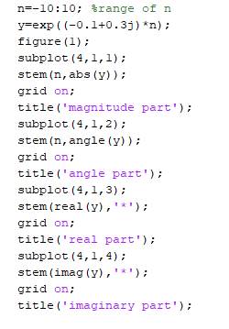

Plot:

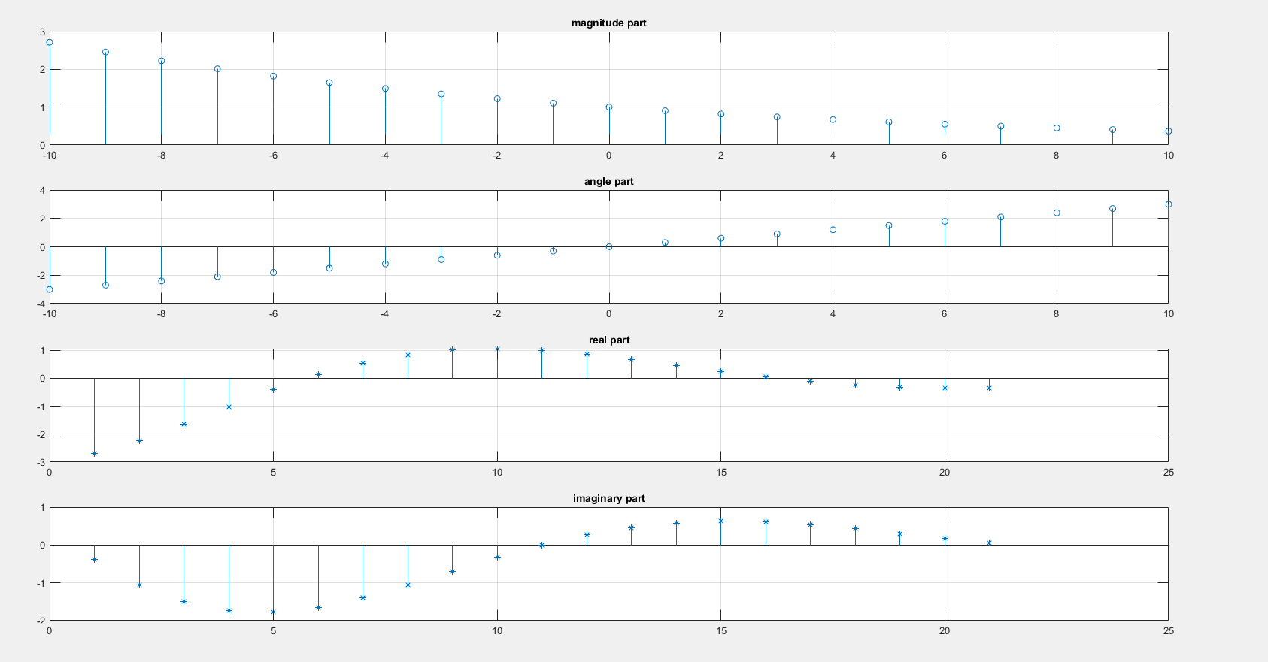

Part 2

Q5

Code:

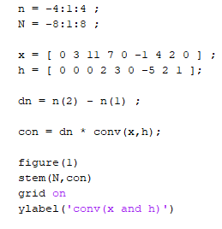

Plot:

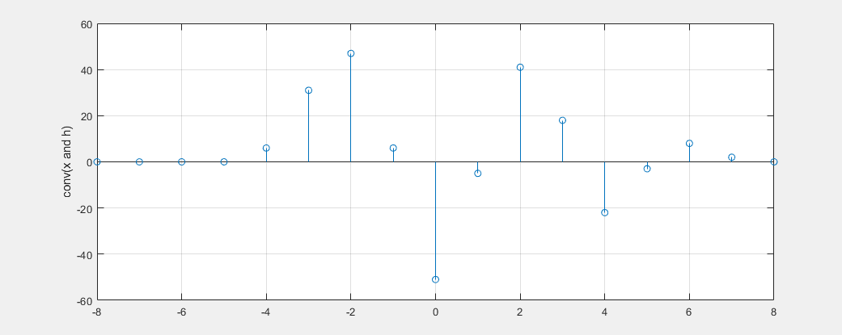

Q6

Code:

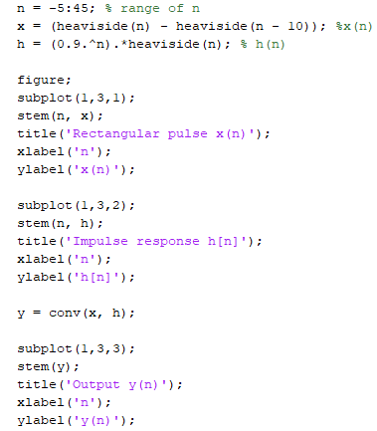

Plots:

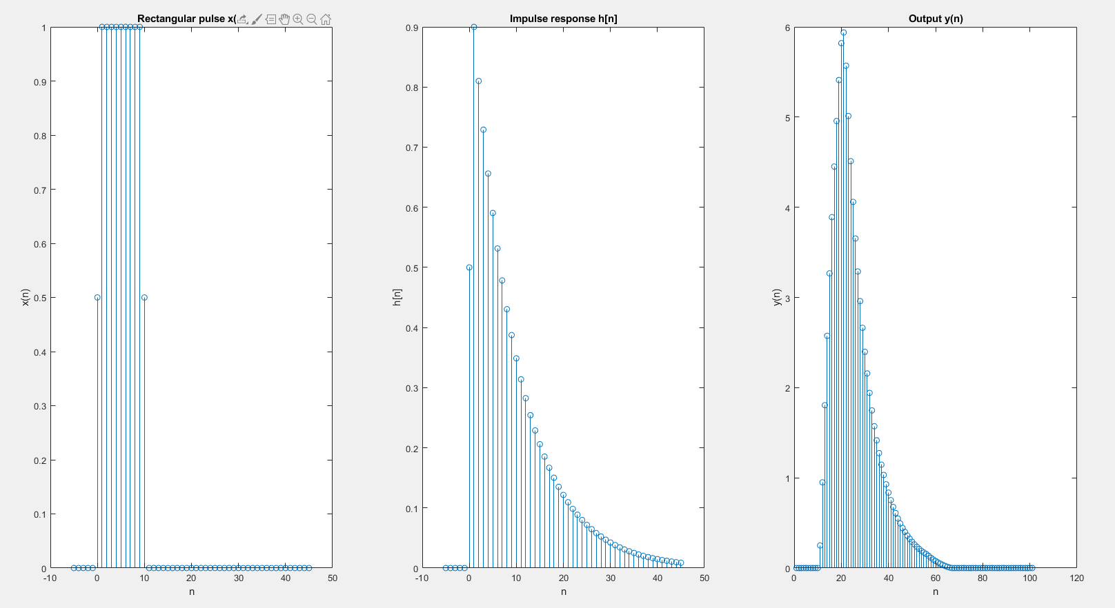

Part 3

Q7

1. Code:

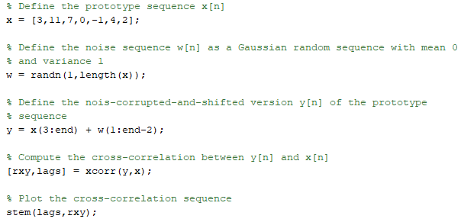

Plot:

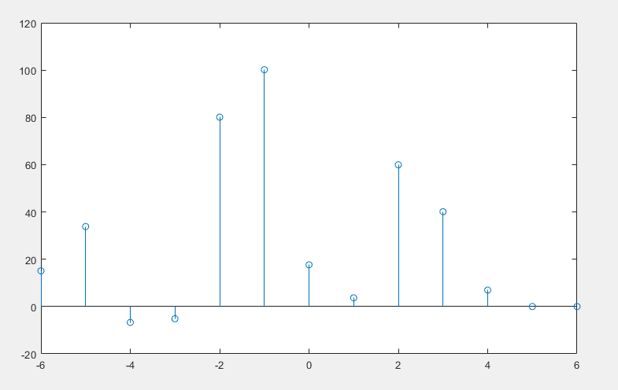

1. Code:

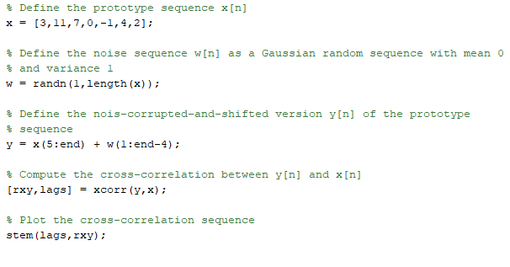

Plot:

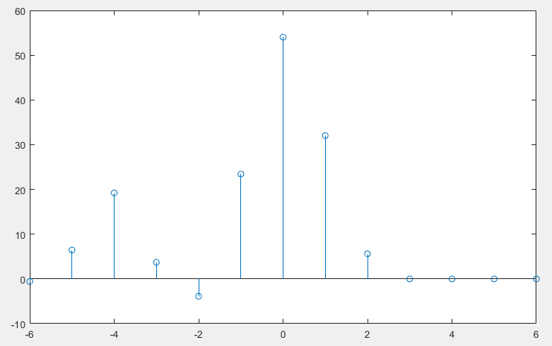

Q8

1. Code:

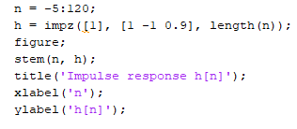

Plot:

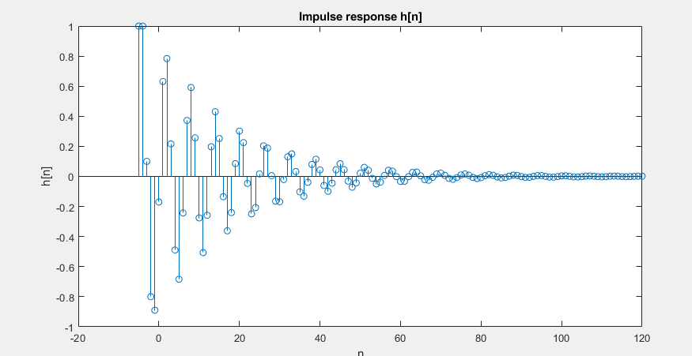

1. Code:

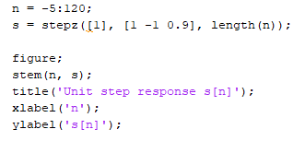

Plot:

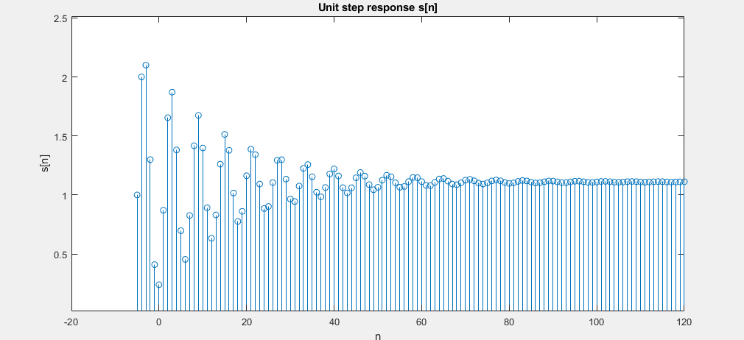

1. **1 - p + 0.9p^2 = 0**

Solving for p, we get the roots

p1 = 1 and p2 = 0.9.

Both of these roots are inside the unit circle, so the system is stable.

Q9

1. Code:

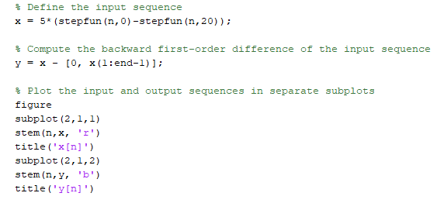

Plot:

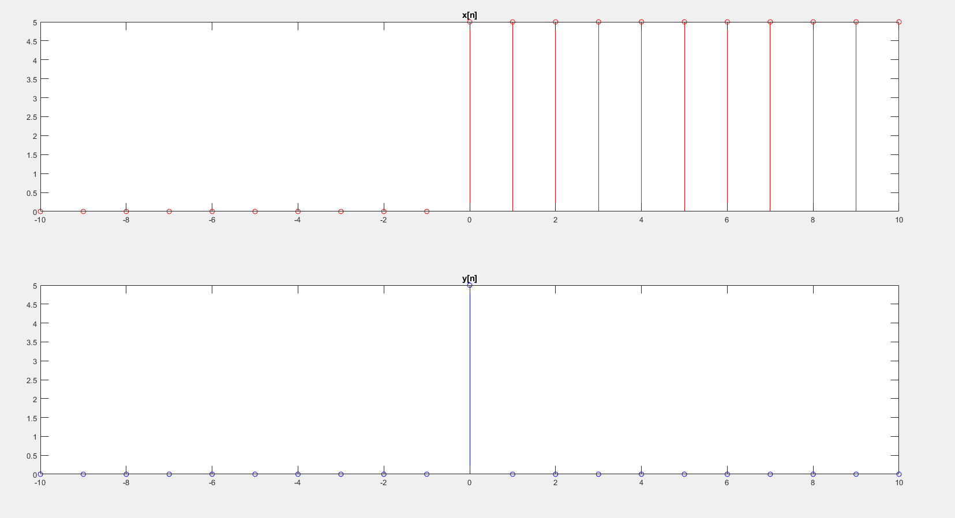

1. Code:

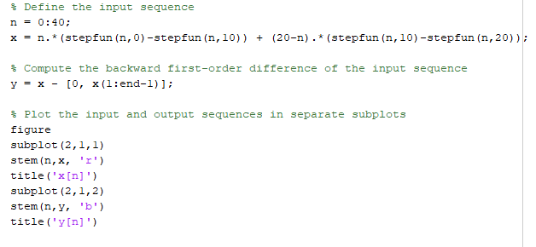

Plot:

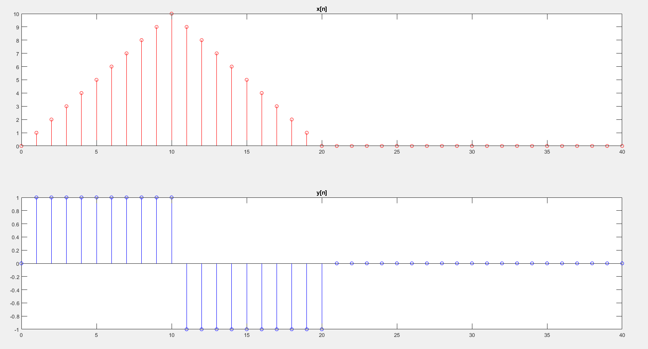

1. Code:

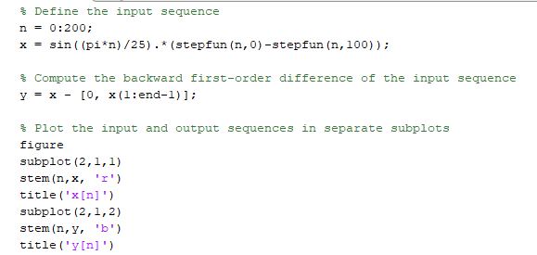

Plot:

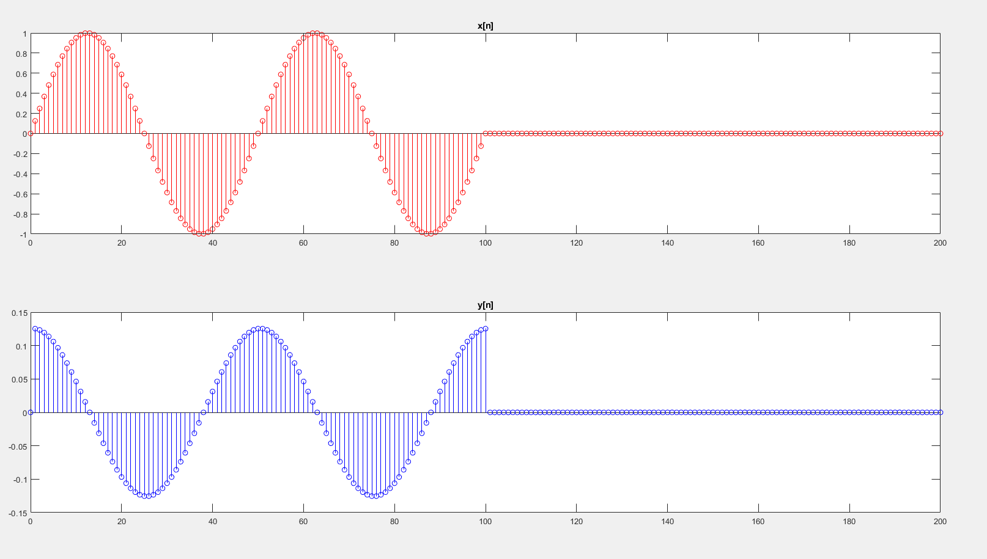

Part 4

Q10

Code:

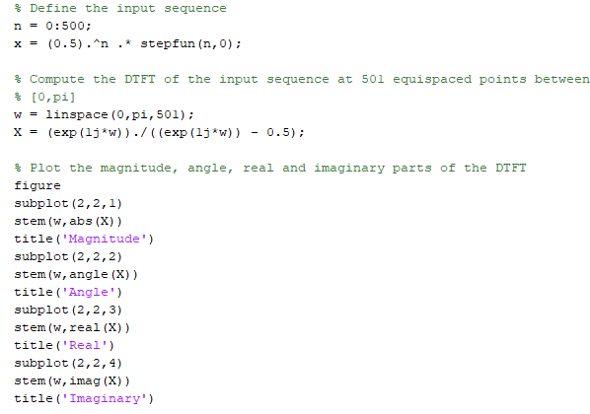

Plot:

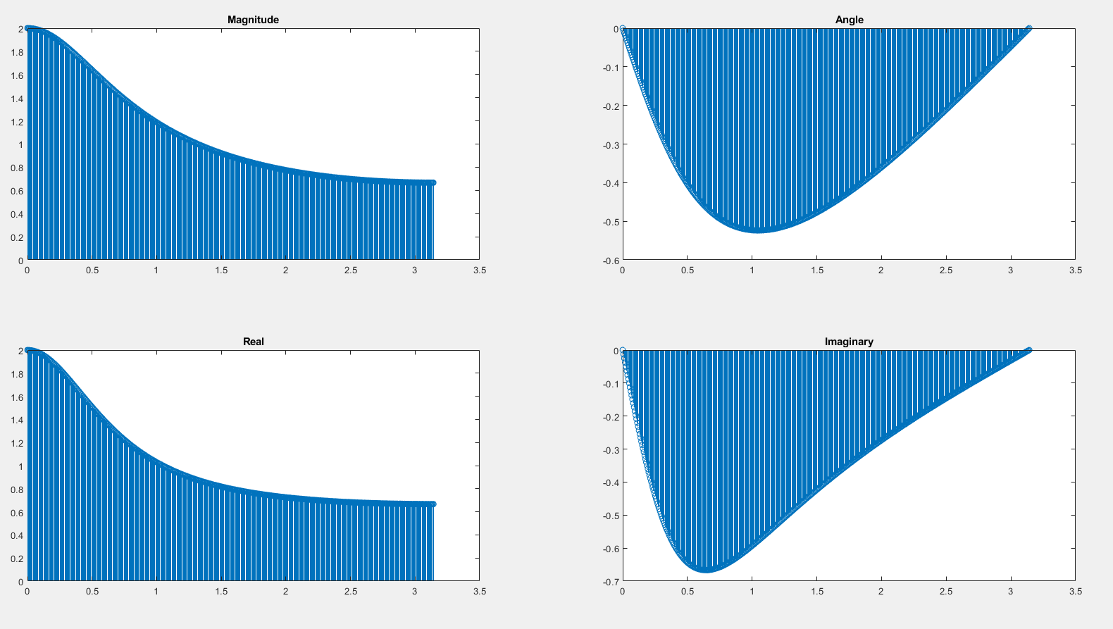

Q11

Code:

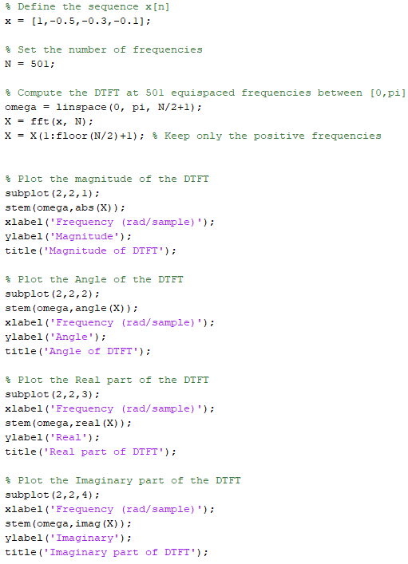

Plot:

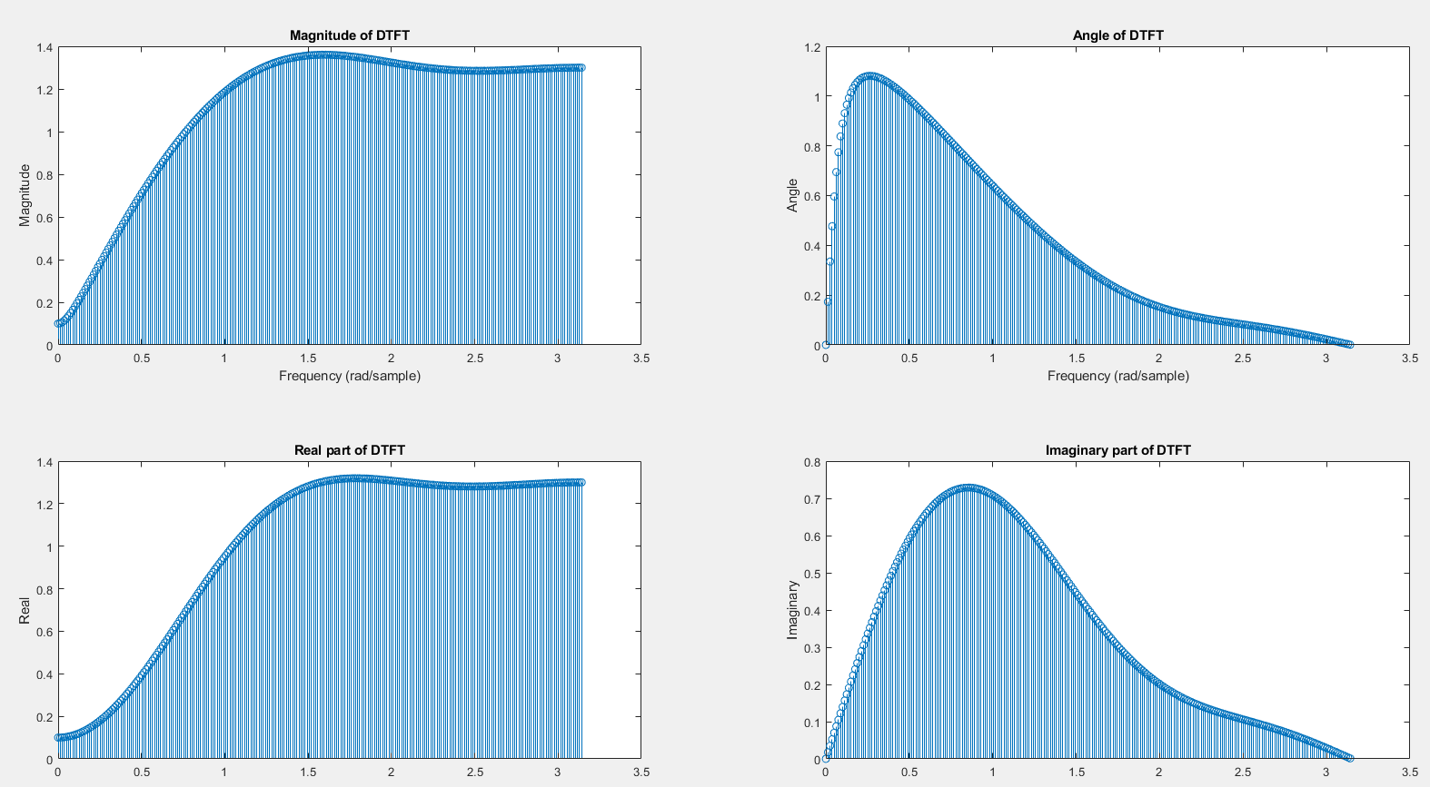

Q12

Code:

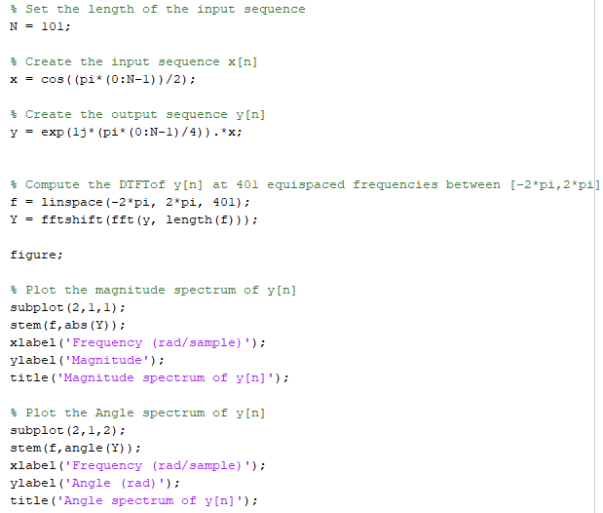

Plot:

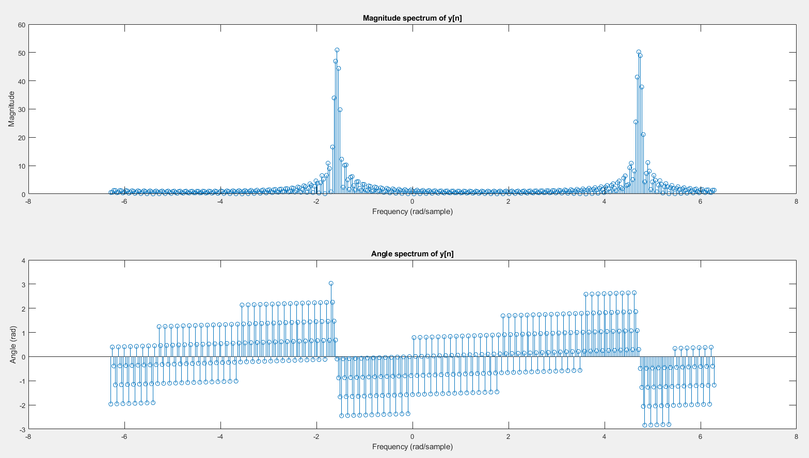

In the given sequence y[n], the input sequence x[n] is multiplied by a complex exponential term e^(j * pi * n / 4). This operation is known as modulation, and it shifts the frequency content of x[n] by a certain amount.

In this case, the frequency of the complex exponential term is (pi * n) / 4, which means that it oscillates at a frequency of pi / 4 radians per sample.

This means that the frequency content of y[n] is shifted by pi / 4 radians per sample with respect to the frequency content of x[n].

The magnitude and angle spectrum of y[n] will therefore be different from the magnitude and angle spectrum of x[n].

The magnitude spectrum of y[n] will have the same shape as the magnitude spectrum of x[n], but the frequencies will be shifted by pi / 4 radians per sample.

The angle spectrum of y[n] will also be different, as it will contain the phase information of the complex exponential term in addition to the phase information of x[n].